|  |  |
| --- | --- |
|  | Planning Documentation |
|  |  |
|  | Ewan Donaldson ec1520347  HND Computer Science |

Table of Contents

Analysis of the Task 2

Aims of the project assignment 2

Requirements 3

Key Factors 6

Resources and Materials 6

Information Sources 8

Survey Monkey Questions and Results 9

Scoping the Project 12

Questions and Answers 12

Additional Notes 13

Analysis 14

User Requirements 14

Platform Restraints and Understanding of Device Requirements 14

Design Aspects for a Specific Device 16

Colour: 16

Logo Details 17

Navigational Map /DATABASE STRUCUTRE 18

Navigational Map 18

The database structure 19

Story Board Demonstrating Interaction 19

Screen Layouts 22

Design of Workable User Interface 24

A list of features 24

Design of Icons 25

List Media Elements 27

Images Files 27

Audio Files 28

Project Plan 29

Gantt Chart 29

Testing Tables 30

# Analysis of the Task

I have been tasked with creating a mobile web based application for an organisation named Amcan. The purpose of this application is to fill a gap in the mobile application market with regards to books. The application must have four categories of books with 5 different books in each category. The application is required to include multiple attributes such as: text, images, data links to internal pages and an embedded google maps.

The security of this mobile web based application must consist of a one page login to receive additional features which can be achieved through the use of an external database or isolated storage on the mobile device.

I am not required to but am allowed to use audio to further enhance to application. The application is required to be of a responsive design which means that no matter what size of screen it is on it will scale to fix it. Also multiple screens must be used to navigate throughout the application and all of which should be easy to use and read.

# Aims of the project assignment

I have been asked to do a few tasks throughout the whole process of the graded unit. I am required to do the following:

* “Interpret the needs of the brief”
* “Gather information to clarify the brief”
* “Decide upon and develop a design approach”
* “Carry out development”
* “Evaluate the product and your performance”

Along with this I will meet with my assessor to have a conversation about what I have done over the past week, usually these weeks are weekly. I will create weekly diaries which allow me to record the progress I have achieved to then use this as proof in my discussion with the assessor.

The application is required to allow a user to view 20 different books from four separate categories and to allow the user to purchase one of these books once logged in by using PayPal. The application is required to be responsive which means that it will scale down depending on screen resolutions.

I am developing this web based application of which is created using html, php, JavaScript and css. These programming languages are the most common programming languages used for developing websites, html is common code for generic positioning and collating all the code together, JavaScript is used to animate certain objects and such to make the application seem more professional, css is used for styling certain things such as div tags which are places for code within html, and finally php which is used in two different ways. The php is used on the websites to allow for functions such as logging in and registering accounts, for a shop and a purchase history for each individual user account. Another use of php was on the online application phpMyAdmin which I speak of later on. PhpMyAdmin is an application that allows for me to create a database with all records of user created accounts and books for the user to purchase along with the purchase of said books.

# Requirements

Functional Requirements are requirements and descriptions of what the mobile web based application does, it is the physical attributes of the application that the user interacts with. Some of the functional requirements are the following;

* Login Form – This is a place where the user can input their username or email, depending on what the developer of the application has chosen to put, and the password to enter the application with a linked account. There would also be a link to the register form to allow the user to create an account if they hadn’t already.
* Register Form - This form is where the user will create an account to access the application through the login form. It will create a new record in the database where parts of which will be encrypted to increase its security, especially when it’s hosted on a cloud server.
* Purchase History – Purchase history is a place which requires the user to have logged in. It displays all the prior purchases relating to the account it is connected to and should display nobody else’s information or else it is an Admin account or has been created incorrectly.
* Book Library Dropdown – To view a summary and image of the book when in the library (which is a set of pages used to solely view the book but not purchase it), you can click on a button to open the dropdown, of which was originally hidden.
* PayPal payment – This is a third-party screen which opens up when the option to use the PayPal payment method is chosen. This uses the PayPal API (Application Programming Interface) which is what allows application and website creators/developers to easily implement this payment method into their program of choice.
* Splash screens – This is a screen which is usually at the start of the application, it is essentially a loading screen. This is used to pre-load the pages to next be used, for example login.php which uses the login form.

Non-Functional Requirements are all requirements that do not come under the category of functional requirements. A non-functional requirement describes how the application should behave and does what it does, examples following;

* Scalability is a non-functional requirement which makes the mobile web based application work on multiple devices. What this does is allows the people to make their site scale everything such as buttons and textboxes/input boxes and then make it fit on any screen. This would work on both computer screens and mobile screens even though they are drastically different resolutions.
* Usability refers to how user friendly something is. The developer of a web based application must ensure that it is very easy to navigate throughout the site and to also perform tasks such as logging in on the login form.
* Reliability refers to whether or not a web based application can encounter an error and still run properly without crashing. Developers would test this by entering in “normal”, “extreme” and “exceptional” data. Normal data is regular data that clearly would work, extreme data is data just on the parameters of the procedure being tested and exceptional data is data that is outside the allows parameters which should come back with an error and not a crash of the application.

Constraints are certain factors that would affect the development of the product. The extensity of these constraints are usually agreed between the client and the developers during the creation of a specification requirement.

* Time is one of these constraints because the time scale set for an applications development will greatly affect the production of said app. The reason for this is because when the timescale is shortened the developers may either have to;
  + Work longer hours due to the large amount of work needed to be done in such a limited time space.
  + Agree on a more simplistic version of the application with the client to fit within the time scale of app’s production, which could result in removing components/features.
  + Discuss with the clients a lengthened due date for the application further throughout development, which could result in reduced pay or none at all throughout the extended period.
* Budget is another constraint because when a budget is set by the client having discussed costs with the developers, this gives them another outline of how to create the application with regards to a few things;
  + The developers may end up using less of their staff members to develop the application as they may not be needed or they may not be able to use them with the limited pay.
  + The staff may have reduced pay while developing the application, this is not usually the case but in circumstances where the company developing the application has no other choice but to accept the offer for a reason such as lack of demand for the style of application they create, this may occur.

# Key Factors

Time and quality are both interchangeable resources because usually there is a trade-off between the two. When there is a greater amount of time to develop a product it allows the creators to do more with it, examine it many more times to ensure its not in any way faulty and such. However when the time is short then quality can drop significantly because the creators can rush the development as stated earlier. There are other variables when discussing time and quality such as budget which itself could influence quality but time and quality are the two primary influences of one-another.

Resources is a key factor for a project as resources refer to what is available to the developer, in this case what is available to me in the sense of software. When the developer has more resources it therefore gives them multiple ways to work on a project, this can be very beneficial as it can allow them to create a more intricate product for the client as long as it has been agreed on within the requirements specification. However when a developer has very limited resources it can then hinder what they may be able to do for the client. Later on in this report I list what resources are available to me and a description about what each one of them does.

# Resources and Materials

The resources that I have used consist of both local applications and ones hosted online. One of the online applications I used was Survey Monkey which allowed me to ask a varied group of people questions about how the application should be styled and other things which I will talk about in the Information Sources part of this report. Survey Monkey is an online application created by Chris Finlay and Ryan Finley, which allows you to easily create an online survey through the use of multiple helpful tools and to then upon its creation allow you to export it through multiple methods, for example:

* An HTML (Hypertext Mark-up Language) link
* A downloadable text file
* A public link on survey monkey that anyone can access

To get results for my application I had asked multiple people from my computer science class to answer my survey due to them doing the same project therefore having ideas of their own that they can express through my questions. I also asked my parents to answer my survey to get a perspective from a consumer.

I used Microsoft word which is the most commonly used word processing application to type up this document. Microsoft word is an application that comes with the Microsoft software packages that you can purchase. I am using this application because I have a large amount of experience with this due to it being commonly used on multiple devices meaning I have constant access to it.

I used Microsoft project 2010 which allowed me to make a gantt chart which is a collection off all the tasks that need to be accomplished and corresponding timescales. Microsoft project is a software that was installed on the college computer which I had already had experience with. Microsoft project is used to make a collection of all the tasks a single person or a company is required to do and to then create a timescale to fit within the client’s requirements.

Sublime is a piece of software that I use to do html, php and css coding. I have downloaded sublime from an online source as it is a free to use application which you can purchase if you want to assist the company that created the product. I have used this before because they use multiple methods to colour the text of certain pieces of code to assist with its readability as well as it also automatically indenting code, again helping with readability.

Notepad++ is another piece of software that is used for coding multiple programming languages. I have used this product before due to it being similar to sublime with it utilising multiple colours to aid with readability. This program is usually pre-installed on computers and is the default program for many file types that usually have code in them such as php, html, css and such.

The program phpMyAdmin is an online application that is used to create and host a database. This application allows the user to use php to code the database and its content/data or to use a GUI (Graphical User Interface), and to then run queries throughout. I have used this many times, using both the GUI and php, to create databases for other projects. The reason for this is because it is a very effective piece of software that allows me to easily create my database with an effective amount of assistance.

Fluid Ui is an online application that allows for the user to design a mobile application and to emulate it for a basic/simplistic example of how the application would run. I have used this program before to design an application for HCI (Human Computer Interaction) class which means I have a great amount of experience. I have also chosen to use this because it is a free software with an expansive amount of capabilities given to me to design my application exactly the way I desire. The fact I can emulate my mobile application is very useful because it allows me to see potential errors in my design and to amend it so it works but still works within the user’s requirements.

# Information Sources

The methods of obtaining my information for this project were through multiple methods, one of which was by using Survey Monkey as stated above in the Resources and Materials part of this project. This online program allowed me to collate multiple answers to specific questions that I had chosen to ask from people of different ages and genders to create a diverse set of answers.

Bootstrap was another source of information I will use as this is some code that I can link into my website for free which allows it to scale properly. This is very useful as this site needs to be able to work on both mobile devices, as it’s a mobile web based application, and on a computer screen, as it is a standard website as well. Bootstrap scales certain things such as buttons and div tags to fit the screen which is highly useful, which is why I am using it.

Another source of information is when I asked my client, “Amcan Books”, multiple questions for which I received answers and some additional notes. These questions and answers are seen below. The reason I asked the client questions about the website is because they will be the ones with a rough idea set-up with what they want and they will have very detailed answers to my questions. I was only able to ask a certain amount of questions which is why I made sure to ask the most important ones.

Online sources were used for the answers of simplistic questions which I was unable to ask due to the limited questions available to me. I mainly will use online sources to obtain some slight assistance with coding and of course the survey monkey application online of which I have spoken about at the beginning of this section of the report.

## Survey Monkey Questions and Results

I was required to ask multiple questions to people who would potentially use the application and since the age range if very wide I managed to collate a large handful of answers which will aid me in the design of the web based application.

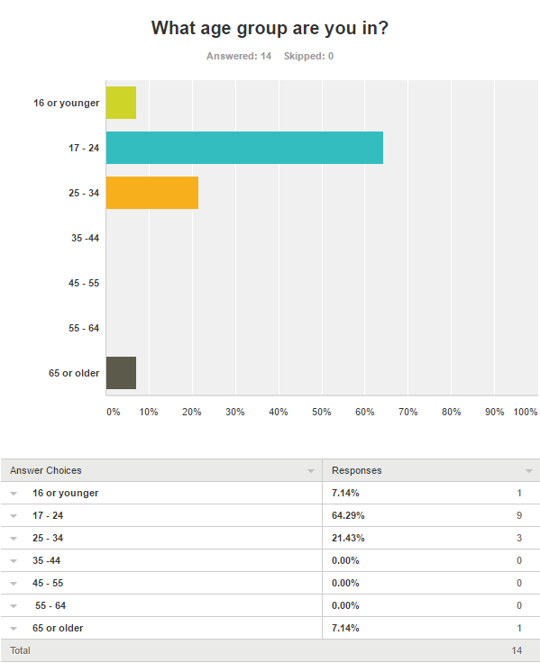

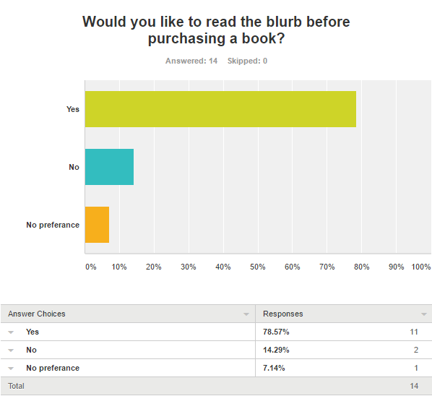

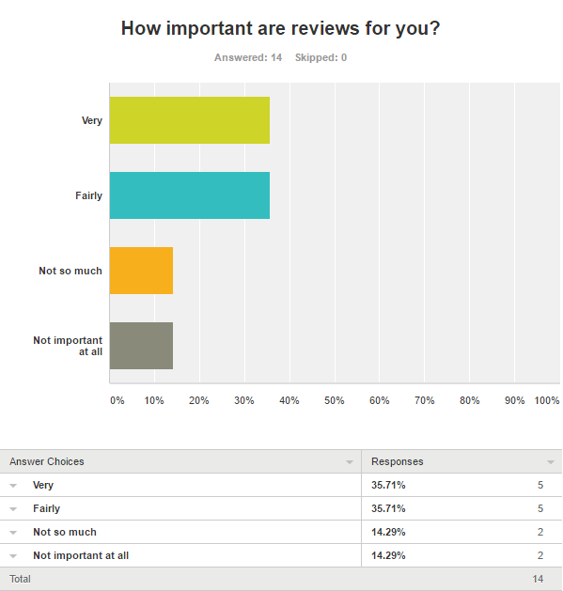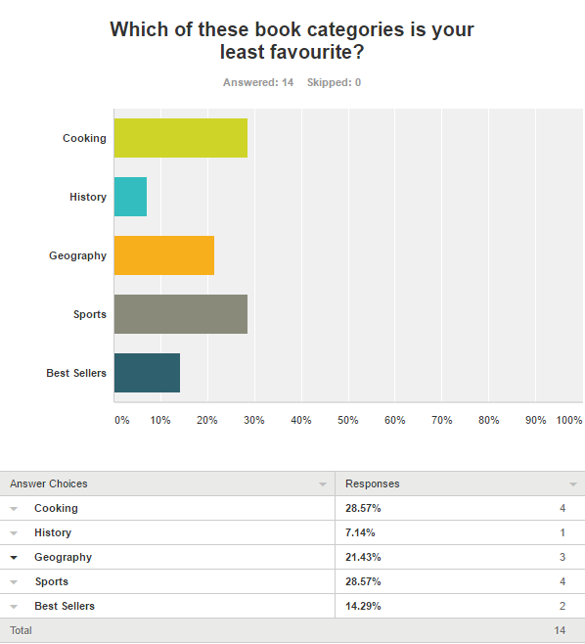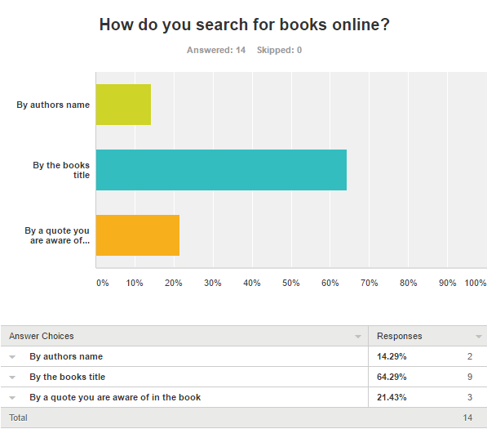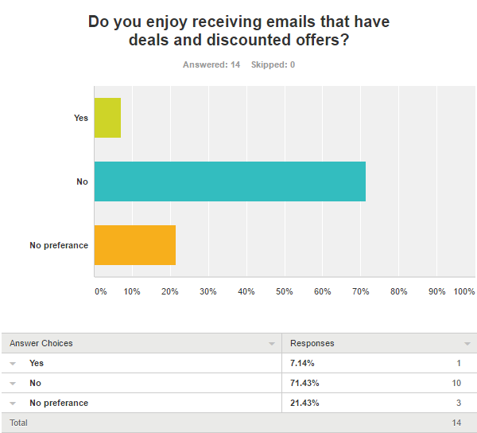

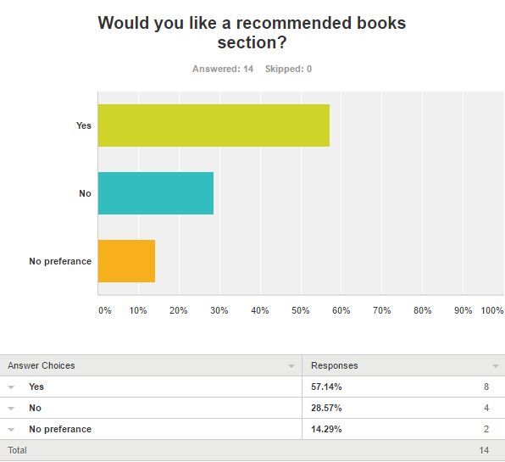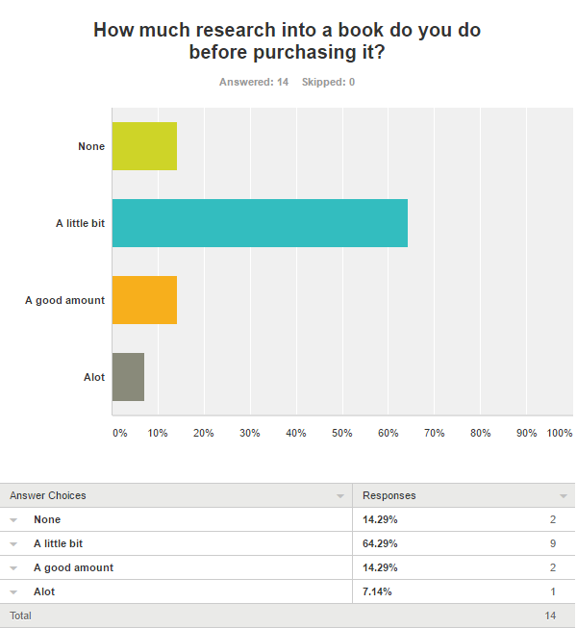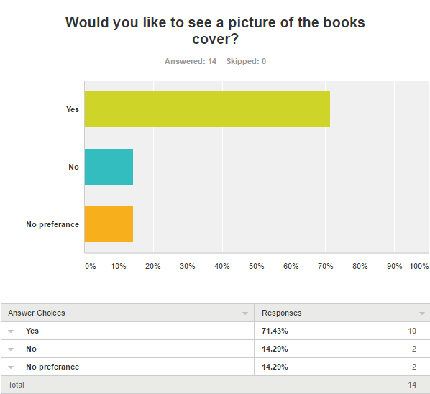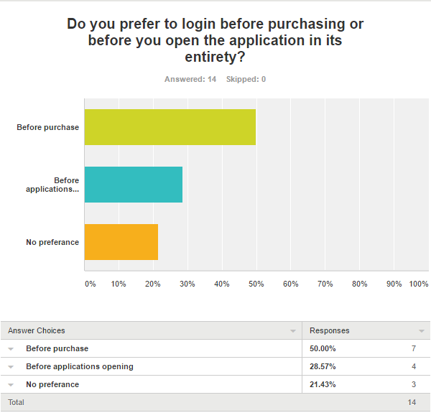

# Scoping the Project

I asked the client questions with regards to the web based application and found out multiple answers that were very useful and I also took some additional notes

## Questions and Answers

|  |  |
| --- | --- |
| 1 | What age is the target audience? |
|  | The audience is all ages but mainly adults. |
|  |  |
| 2 | What does it mean by existing packaged solutions? |
|  | Examples of these packages are bootstrap, pay pal features and such. |
|  |  |
| 3 | What are the different departments? |
|  | The departments are as follows Sales, Accounts, marketing, Purchasing. |
|  |  |
| 4 | Do we require an Admin account? |
|  | Not required but very good to have. |
|  |  |
| 5 | Does the user need to login during the start-up of the application? |
|  | It is not a requirement but you can setup the login system whichever way you would like. |
|  |  |
| 6 | Is there any particular colour scheme? |
|  | No colour scheme is pre-set. |
|  |  |
| 7 | What type of website is required? Parallax scrolling for example. |
|  | It is your choice what type of website is required. |
|  |  |
| 8 | How many separate pages are required? |
|  | Nothing has been pre-set. |
|  |  |
| 9 | Is a review system required? |
|  | It is your choice whether you include this in your website or not but it would be useful. |
|  |  |
| 10 | Does the user have the ability to see their previous orders? |
|  | It is your choice whether you include this in your website or not but it would be useful. |
|  |  |
| 11 | Are recommended products required on the front/home page? |
|  | It is your choice whether you include this in your website or not but it would be useful. |
|  |  |
| 12 | Do the accounts have Usernames or use Email addresses? |
|  | The user’s accounts use Emails. |
|  |  |
| 13 | Do we sell e-books as well as physical copies? |
|  | No, only physical books are sold. |
|  |  |
| 14 | Is there a minimum stock amount required? |
|  | The minimum is 20 products slit up among 4 categories. |
|  |  |

## Additional Notes

The category choices of which we choose 4 from are History, Geography, Sport, Cooking, Best sellers and Special deals. You MUST also use the amazon server, pay-pal feature, and a custom logo. Also you can use limitless tables in your database.

# Analysis

## User Requirements

The users will be able to make accounts which use an email and a password to login. These accounts will ask for extra information such as first and last name, all this will be used to create a unique user id which will be used to link the tables in the database. To ensure that people have secure accounts I will use sha-256 encryption to encrypt the password. Encryption is a process that changes the password into a code which requires a key to open which only the user the account is linked to will have. The reason encryption is required is because as everything is hosted on an off-site server it means that everything is less secure as transmissions to a device could be intercepted by people attempting to obtain illegal access to an account, encryption would therefore prevent the person hijacking the account as they would be unable to see the password due to it being encrypted. All this is done because of the Data Protection Act 1998 which makes the company or organisation holding the users passwords and information, by law required to keep all information safe. This legislation of course does other things but encryption only refers to the fact that data must be kept secure and safe.

Users will, as stated earlier, enter in their details to register an account which will be saved to the database of user accounts. There are error prevention methods in place in case the user enters in some incorrect information. If the user encounters an error, the error message will be displayed and will then be allowed to re-enter all their information to make another attempt. Upon logging in the user will now have full access to the application until they sign out which would then cause them to have to login back in. The user would expect a simplistic navigation in the form of a basic navigation bar or some backwards and forwards buttons. This is all done by creating a design with a consistent navigation method throughout the website. The way this is achieved is by ensuring all the buttons are the same style and in the same place on each and every page.

## Platform Restraints and Understanding of Device Requirements

One of the restraint of a device can be related to the amount of data a person can use on their mobile devices. Data comes in the form of 3G or 4G and is used to give a mobile device internet connection while not in wireless contact to a router, data connects to a cell tower and usually has a limit in gigabytes for the user to use. When using data due to the limit set on it for downloading files I must make the website as compressed as possible therefore allowing the users to navigate throughout the pages whilst having used as little data as possible. To compress the file down to a minimum size, I can compress the images through the use of lossless compression. Lossless compression is where the image is compressed but the image quality is maintained, the benefit of this is that no matter what the screen size is the image will maintain a high quality. Another way I could compress the file is by removing any unrequired code, by doing this I am making all the files smaller and therefore to download them with a smaller data usage required.

## Design Aspects for a Specific Device

### Colour:

The following colours consist of:

Light Orange - #E89F38

Dark Orange - #DD8B19

Grey - #EDECEB

Black - #000000





All these colours are used because they are very easy on the eyes, especially a light grey background with black fonts. The reason for the two tones of orange is to give that website a nice part of colour. The primary colours will be the grey and black with a slight hint of the orange colours to make everything more eye catching which the user will appreciate.

The colour scheme will be consistent throughout the entire website, it is important to keep a consisted style throughout as it will make the site seem more professional to the users.

### Logo Details

This logo keep within the theme of multiple book publishers using creatures as their logo, examples of which are puffin, ladybug, and penguin books. I thought of keeping up with this trend would be beneficial for the company, therefore I chose a snail.



## Navigational Map /DATABASE STRUCUTRE

### Navigational Map

The following is the navigational map beginning from the splash screen.

SIGN OUT

CART

CATALOGUE

GEOGRAPHY

BEST SELLERS

COOKING

HISTORY

INDEX

REGISTER

LOGIN

SPLASHSCREEN

The way this navigation works is the splash screen opens originally and then takes the user to the login page, the user can then register there if they choose to however an account must be linked if the user is to utilize the website. Upon logging in the user can go through all the options to see different parts of the site, afterwards the user can sign out and that ends the session so the user is required to log back in.

### The database structure

Users

Orders

Shop

Forum

These are the tables within the database.

## Story Board Demonstrating Interaction

|  |  |
| --- | --- |
| The Page | Users Interaction Method |
|  | Splash screen  This page is in place is the first screen the user comes across. The user does not interact with this page in any way as it loads the next page for you. The purpose of this page is to preload the next page so the user isn’t waiting for a long loading time. |
|  | Index / Library  This page acts as a home page but its main purpose is for displaying all the books categories available in which would then upon clicking would change the page to another with information on the books of the chosen category.  There is also a navigation bar at the bottom of which will use icons to move throughout different sections of the mobile web based application. |
|  | Display Pages  This is an example of the four pages used in this style, one four each category which will be accessed from the previous page. When the user presses the plus button it opens additional information below the details of the selected book. The user can also press the back arrow to back to the previous page.  There is also a navigation bar at the bottom of which will use icons to move throughout different sections of the mobile web based application. |
|  | Catalogue Page  This page is separate from the library but performs a similar function. This page does not have any sorting function as seen in the library as this page on has the books name and author. Here you can navigate to the cart by adding a book to the cart.  There is also a navigation bar at the bottom of which will use icons to move throughout different sections of the mobile web based application. |
|  | Cart Page  This page is where users send all there book selections and can specify how many of each book they would like. The user can also press the back arrow to back to the previous page and add another book.  There is also a navigation bar at the bottom of which will use icons to move throughout different sections of the mobile web based application. |
|  | Sign In / Login  This page allows the user to enter in an Email and Password which will attempt to match one of the data entries on the database of users. If the details entered don’t match suitable errors will be displayed however if everything works it will open a loading page which is essentially the splash screen but for a shorter time and then load the index / library page.  There is also a navigation bar at the bottom of which will use icons to move throughout different sections of the mobile web based application. |
|  | Register Page  This page allows the user to enter in a first name, last name, email and password twice to ensure the user enters the password they desire. If the email isn’t already linked to another data entry on the database then it will display an error but if all user entries are suitable then the account will be created and the user will be redirected to the sign in / login page.  There is also a navigation bar at the bottom of which will use icons to move throughout different sections of the mobile web based application. |

## Screen Layouts

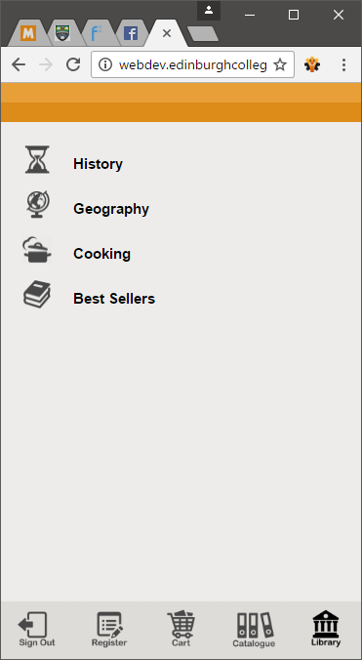The screen has been setup primarily for mobile as it’s a mobile web based application but It will be made to scalable on a computer screen while still being suitable. By making it scalable in such a way, it will be able to be used on almost every device no matter what the resolution is. This scaling can be achieved by using bootstrap as it scales and is free to obtain but I will also use code such as max-width and min-width, therefore limiting the sizes of things on a different resolution screen.

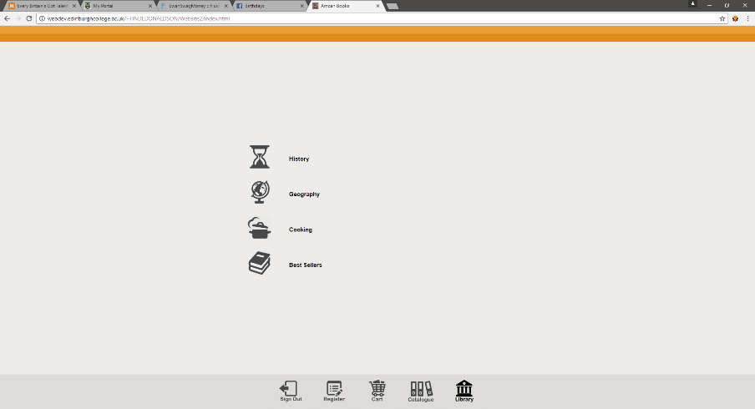

## Design of Workable User Interface

The user interface of this mobile based web application will be simplistic and designed so anbody will be able to read it regardless of any disability, for example colour blindness. The reason for this is because of the disability and discrimination act 1995 which makes developers ensure that their sites are able to be viewed by everybody regardless of any disability they may have. To make the text most readable I have chosen the light colours background and then dark fonts which therefore stand out. I have also added a bit of colour to ensure that the site will not look boring and used a reasonable amount of icons to make everything seem more appealing and professional. Overall the interface has been designed to ensure that people can use it with no issue and to see it as a professionally designed site.

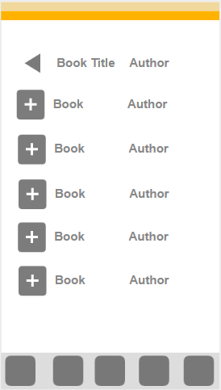

## A list of features

This application will have the ability to listen to the blurb/summary in the form of an audio file. This audio file will have a very simplistic play button next to every summary in the area in which the books image and summary is displayed upon the click of the plus button (additional information button). The main reason for doing this is because of the disability and discrimination act 1995 as stated earlier which ensures that developers make their website suitable for everybody.

## Design of Icons

|  |  |
| --- | --- |
| Icon | Purpose |
|  | This is a favicon which is used as the small icon at the top of webpages usually seen of computers using a web browser such as chrome or IE (Internet Explorer). |
|  | This is the icon used to select the category of best seller’s books. |
|  | This is the icon used for cooking books category. |
|  | This is the icon used for the category of geography books. |
|  | This is for the books within the history category. |
|  | This is used to get to the cart. |
|  | This is used to get to the catalogue of books to purchase. |
|  | This is used to access the library to view all the books |
|  | This is used to go to register an account. |
|  | This is used to sign in with an account saved on the database. |
|  | This icon is used to sign out of the application. |
| C:\Users\Ewan\AppData\Local\Microsoft\Windows\INetCache\Content.Word\Open.png | This icon is used to expand the information on all the books. It shows the user the books image and summary/blurb. |
| C:\Users\Ewan\AppData\Local\Microsoft\Windows\INetCache\Content.Word\BackArrow.png | This icon is used to go back to the previous page. |
|  | This is used as a deselected version of the library icon. So on the navigation bar when not on this page this grey out version will appear. |
| C:\Users\Ewan\AppData\Local\Microsoft\Windows\INetCache\Content.Word\Catalogue.png | This is used as a deselected version of the catalogue icon. So on the navigation bar when not on this page this grey out version will appear. |
| C:\Users\Ewan\AppData\Local\Microsoft\Windows\INetCache\Content.Word\SignOut.png | This is used as a deselected version of the sign out icon. So on the navigation bar when not on this page this grey out version will appear. |
| C:\Users\Ewan\AppData\Local\Microsoft\Windows\INetCache\Content.Word\SignIn.png | This is used as a deselected version of the sign in icon. So on the navigation bar when not on this page this grey out version will appear. |
| C:\Users\Ewan\AppData\Local\Microsoft\Windows\INetCache\Content.Word\Register.png | This is used as a deselected version of the register icon. So on the navigation bar when not on this page this grey out version will appear. |
| C:\Users\Ewan\AppData\Local\Microsoft\Windows\INetCache\Content.Word\Cart.png | This is used as a deselected version of the cart icon. So on the navigation bar when not on this page this grey out version will appear. |
| G:\Graded Unit\Website2\images\AmcanBooksLogo.png  This is a logo for the Amcan Books mobile web based application. This will displayed on the splash screen. | |

## List Media Elements

### Images Files

|  |  |  |  |
| --- | --- | --- | --- |
| File Name | Extension | File Size | Source |
| BackArrow | .png | 22KB | F:\Graded Unit\Website2\images\icons |
| BestSellers | .png | 31KB | F:\Graded Unit\Website2\images\icons |
| Cart | .png | 72KB | F:\Graded Unit\Website2\images\icons |
| Catalogue | .png | 105KB | F:\Graded Unit\Website2\images\icons |
| Checkout | .png | 68KB | F:\Graded Unit\Website2\images\icons |
| Cooking | .png | 772KB | F:\Graded Unit\Website2\images\icons |
| Geography | .png | 43KB | F:\Graded Unit\Website2\images\icons |
| History | .png | 32KB | F:\Graded Unit\Website2\images\icons |
| Library | .png | 83KB | F:\Graded Unit\Website2\images\icons |
| Open | .png | 95KB | F:\Graded Unit\Website2\images\icons |
| Register | .png | 62KB | F:\Graded Unit\Website2\images\icons |
| SignIn | .png | 72KB | F:\Graded Unit\Website2\images\icons |
| SignOut | .png | 83KB | F:\Graded Unit\Website2\images\icons |
| Favicon | .png | 1KB | F:\Graded Unit\Website2 |
| Favicon | .ico | 6KB | F:\Graded Unit\Website2 |
| BestSellers | .png | 31KB | F:\Graded Unit\Website2\images\icons\Darken |
| Cart | .png | 72KB | F:\Graded Unit\Website2\images\icons\Darken |
| Catalogue | .png | 105KB | F:\Graded Unit\Website2\images\icons\Darken |
| Checkout | .png | 68KB | F:\Graded Unit\Website2\images\icons\Darken |
| Cooking | .png | 772KB | F:\Graded Unit\Website2\images\icons\Darken |
| Geography | .png | 43KB | F:\Graded Unit\Website2\images\icons\Darken |
| History | .png | 32KB | F:\Graded Unit\Website2\images\icons\Darken |
| Library | .png | 83KB | F:\Graded Unit\Website2\images\icons\Darken |
| Register | .png | 62KB | F:\Graded Unit\Website2\images\icons\Darken |
| SignIn | .png | 72KB | F:\Graded Unit\Website2\images\icons\Darken |
| SignOut | .png | 83KB | F:\Graded Unit\Website2\images\icons\Darken |
| AmcanBooks  Logo | .png | 82KB | F:\Graded Unit\Website2\images |

### Audio Files

|  |  |  |  |
| --- | --- | --- | --- |
| File Name | Extension | File Size | Source |
| 01 | .mp3 | 3MB | F:\Graded Unit\Website2\audio |
| 02 | .mp3 | 4MB | F:\Graded Unit\Website2\audio |
| 03 | .mp3 | 2MB | F:\Graded Unit\Website2\audio |
| 04 | .mp3 | 3MB | F:\Graded Unit\Website2\audio |
| 05 | .mp3 | 3MB | F:\Graded Unit\Website2\audio |
| 06 | .mp3 | 4MB | F:\Graded Unit\Website2\audio |
| 07 | .mp3 | 2MB | F:\Graded Unit\Website2\audio |
| 08 | .mp3 | 2MB | F:\Graded Unit\Website2\audio |
| 09 | .mp3 | 3MB | F:\Graded Unit\Website2\audio |
| 10 | .mp3 | 2MB | F:\Graded Unit\Website2\audio |
| 11 | .mp3 | 4MB | F:\Graded Unit\Website2\audio |
| 12 | .mp3 | 4MB | F:\Graded Unit\Website2\audio |
| 13 | .mp3 | 3MB | F:\Graded Unit\Website2\audio |
| 14 | .mp3 | 4MB | F:\Graded Unit\Website2\audio |
| 15 | .mp3 | 4MB | F:\Graded Unit\Website2\audio |
| 16 | .mp3 | 2MB | F:\Graded Unit\Website2\audio |
| 17 | .mp3 | 3MB | F:\Graded Unit\Website2\audio |
| 18 | .mp3 | 4MB | F:\Graded Unit\Website2\audio |
| 19 | .mp3 | 2MB | F:\Graded Unit\Website2\audio |
| 20 | .mp3 | 3MB | F:\Graded Unit\Website2\audio |

# Project Plan

## Gantt Chart

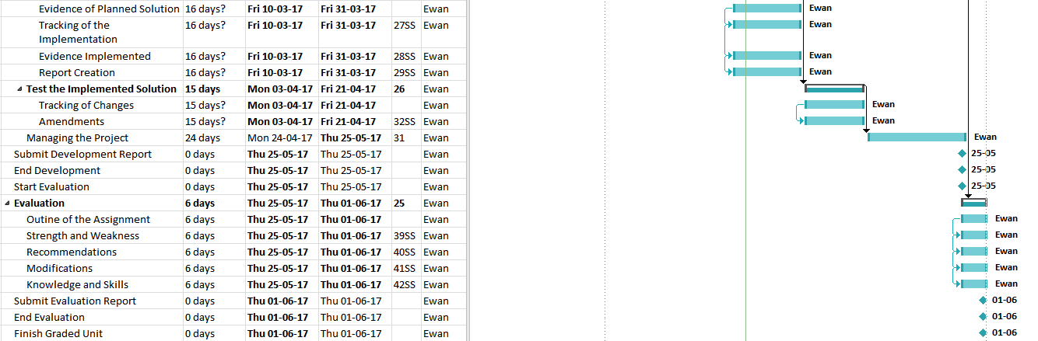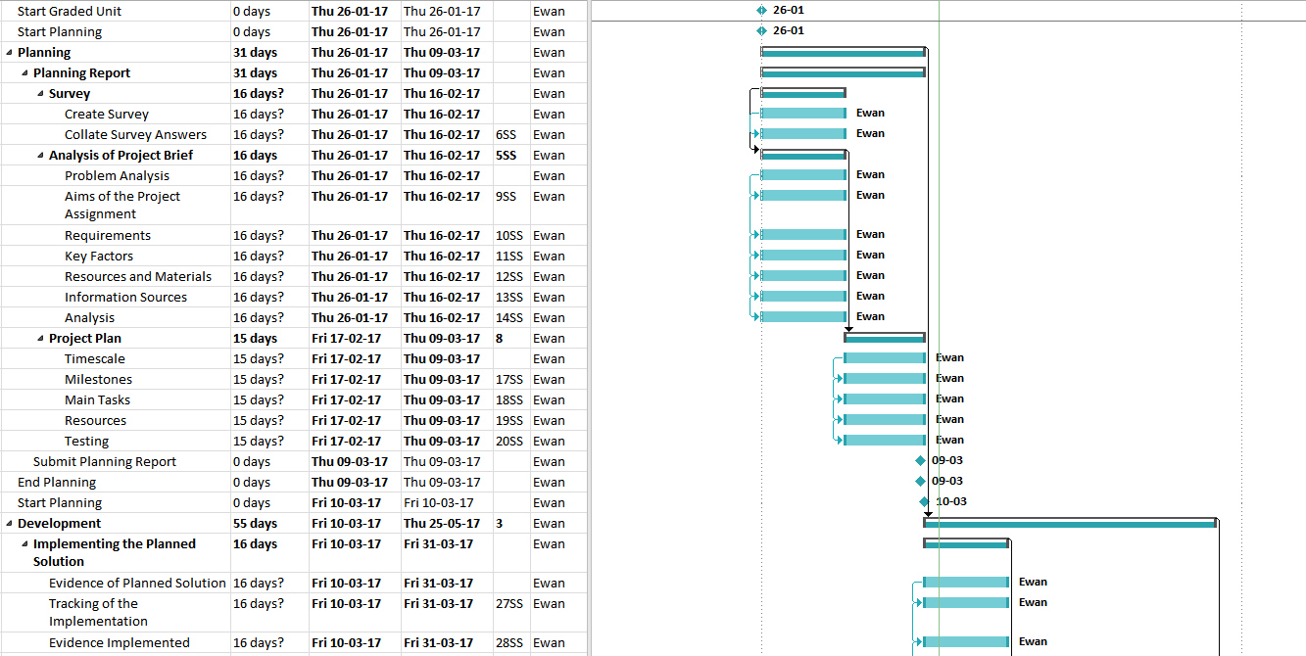

## Testing Tables

|  |  |  |  |
| --- | --- | --- | --- |
| Test Data | Type of Test Data | Expected Result | Actual Result |
|  |  |  |  |
|  |  |  |  |
|  |  |  |  |
|  |  |  |  |
|  |  |  |  |
|  |  |  |  |